Terms of Reference for a senior analyst & quality assurance officer – brave women



PROPOSED TERMS OF REFERENCE OF THE IMPACT EVALUATION OF BRAVE WOMEN
1. Background
The BRAVE (Business Resilience Assistance for Value-Adding Enterprise) for Women Program is a joint initiative between the Industry and Business Environment Support (IBES) program of the Islamic Corporation for the Development of the Private Sector (ICD) and the Women and Youth Empowerment Division of the IsDB aiming to enhance the resilience of Micro, Small and Medium Enterprises owned/managed by women in fragile context as potential engines for innovation, employment, and improved quality of life. The program is currently being implemented in Yemen (2019) and Nigeria (2020) and will soon be launched in Burkina Faso (2021). It has the following five components:
- Business Resilience Capacity Building: Training of 1,500 MSMEs on how to assess risks and determine their business priority by preparing a Business Continuity Plan (BCP).
- Business Recovery Support: Grant matching scheme for over 1,200 MSMEs in pre-selected value chains, on a cost-sharing basis for the procurement of capital goods and services to support business recovery/growth.
- Value Chain Resilience: 60 lead firms and business associations/cooperatives in Nigeria and Burkina Faso supported in protecting vital value chains and upgrading the chain performance, impacting many more SMEs.
- BRAVE IT Platform: An online IT platform will be developed to handle CRM, Monitoring/Reporting and knowledge sharing among project stakeholders.
- Project Management Unit: A unit helping to oversee and administer the project.
The Program is funded by the newly launched global fund for Women Entrepreneurs Finance Initiative (We-Fi), a collaborative partnership among 14 governments, eight multilateral development banks (MDBs), and other public and private sector stakeholders, hosted by the World Bank Group. The program implementation started in 2019 and shall last for a 4-5 years’ timeframe.

In 2019 it has contracted the consultancy firm Ghubril Ltd. to conduct a multi-country program-wide external evaluation of the BRVE Women program in all the three countries. The baseline assessment report for the implementation in Yemen was produced in February 2020. The baseline report for Nigeria is expected in the first quarter of 2021 and that of Burkina Faso during the same period or in the second quarter of 2021.

2. Purpose
The main purpose of the evaluation by Ghubril Ltd. is to assess to what extent supporting Micro, Small and Medium Enterprises owned/managed by women in fragile context leads to innovation, employment, and improved quality of life.

In addition, the evaluation will help investigate the processes of the program to draw lessons on what works and what does not work and to feed further programming.

3. EVALUATION SCOPE
The IBES program is looking to recruit a Senior Analyst and Quality Assurance Officer to support Ghubril Ltd. in undertaking the impact evaluation of the BRAVE Women Program in the three countries with different identification strategies. The three targeted countries are Burkina Faso, Nigeria and Yemen. Burkina Faso was selected to host the experimental randomized control trial (RCT) design while Nigeria and Yemen will receive a Difference-In-Difference design or any other suitable methods such as propensity score matching.
The planned reach of the program is provided in the below table and the detailed results matrix for each country program in the appendix:

Project Components | Burkina Faso | Nigeria | Yemen | Total
Business Resilience Capacity Building (#MSMEs) | 400 | 600 | 500 | 1500
Grant matching scheme  (#MSMEs) | 300 | 500 | 400 | 1200
Lead firms and Business Associations/cooperatives | 20 | 40 | - | 60

3. EVALUATION DESIGN
3.1 Theory of Change
The design of the BRAVE WOMEN Program is based on the following theory of change: providing specialized business training and grant-matching assistance will help women businesses maintain and continue operating in fragile context. Ultimately, it will improve the operational and financial performance of their MSMEs, create new employment opportunities, improve the quality of existing jobs, increase their access to finance and, improve the quality of life for the local communities.
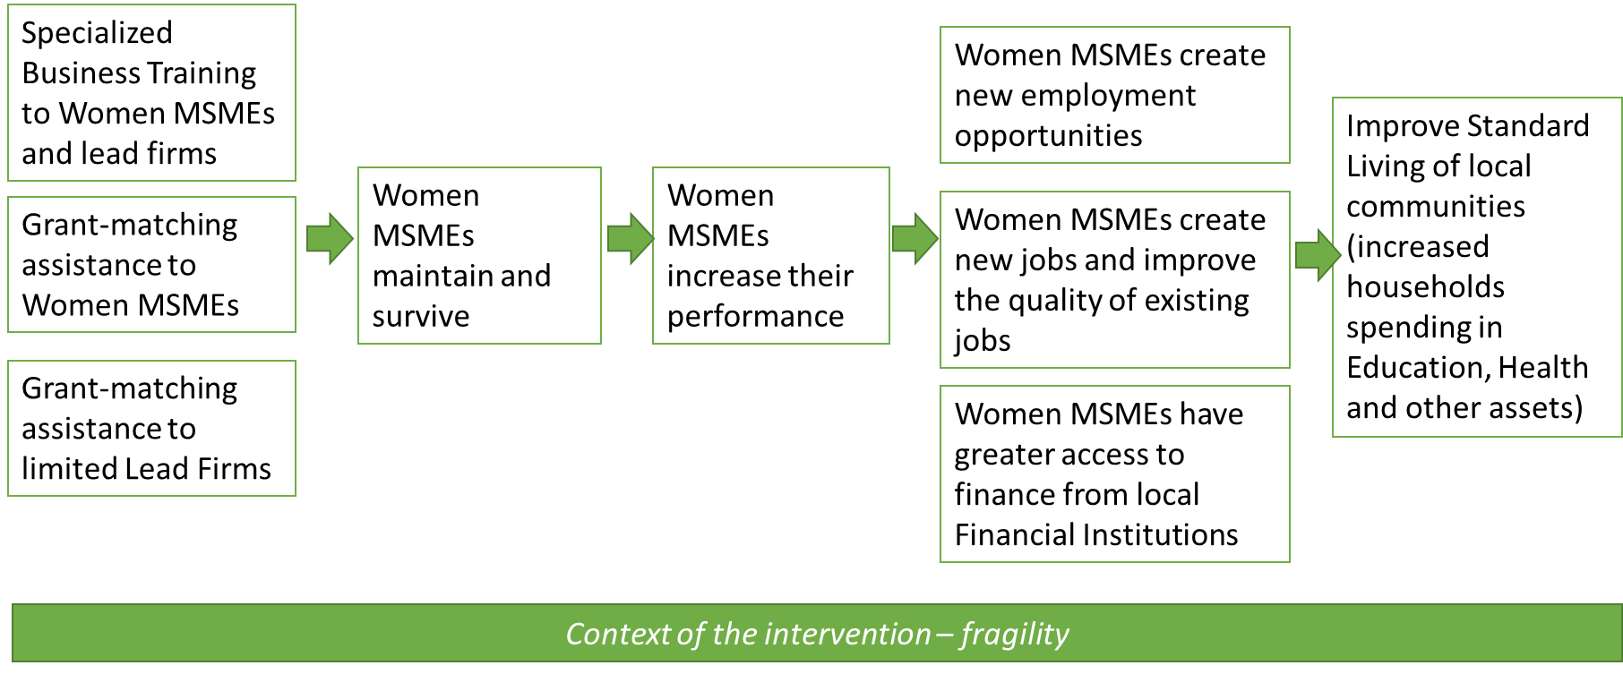
3.2 Evaluation questions
The monitoring and evaluation framework of BRAVE WOMEN requires to answer to two types of evaluation questions: formative/summative evaluation questions and impact evaluation questions.
Formative and summative evaluation questions following the OECD-DAC criteria:
- Relevance: Is the project the right intervention at the right time?
- Efficiency: Are the costs of the intervention reasonable in relation to the actual results?
- Effectiveness: To what extent the project achieved its planned objectives and results?
- Sustainability: Can the project beneficiaries sustain their businesses after the end of the program?
- Scalability/Replicability: Can this project be replicated for businesses in other places?
Impact evaluation questions:
In each country, the exercise will address the following specific impact evaluation questions.
Firstly, the evaluation focused on the impact of BRAVE Women on sales, profitability, introduction of new products/new market channels, and business resilience for treated MSMEs and lead firms (the primary outcomes).
Second, the evaluation explores changes in secondary outcomes among treated firms attributable to BRAVE Women. The indicators of interest are : employment, access to finance, development of business associations, improvement of living standards in terms of households spending on education, health and other assets.
Third, the evaluation identifies any spillover effects on non-treated firms in the same area of intervention for the same primary outcomes of interest.
Last, the evaluation seeks to separate the effect of training only and the effect of training plus grant matching scheme.
Given the strict requirements and the cost of an RCT, it has been decided to limit the RCT to Nigeria and use a Difference-In-Difference approach or any other suitable methods such as propensity score matching in Burkina Faso and Yemen.
Finally, the evaluation team should address in their proposal the common threats faced in similar contexts:
- Attrition: some firms from the control group may leave the study.
- Social desirability: the respondents may provide favorable responses to expect more benefits from the intervention.
- Spillover: control firms may talk to treated firms and change their behaviors.
- Ethical concerns: denying treatment to eligible firms may be seen as an ethical concern.

4. METHODOLOGY
The selected consultant/research must prepare first an inception report following review of literature and reference documents. The inception report details the methodology with an appropriate sample size and specify mechanisms that will be adopted to avoid selection bias.
The evaluation needs to identify two treatments groups and one comparison group:
- Group 1: training plus grant
- Group 2: training only
- Group 3: comparison group (no training, no grant)

Taking into consideration the security context of each country, these three groups will be monitored to the extent possible throughout the Program implementation using the below indicative framework:
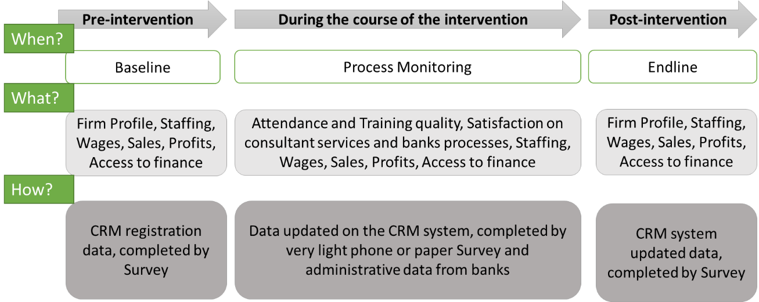

5- COMPSITION OF THE current EVALUATION TEAM and expecte role of the senior analyst nd quality assurance officer
- Research Assistant: The research assistant will support the senior consultant in the field, and follow up on the implementation of the evaluation. This individual should have a research background and at least a bachelor’s degree.
- Country Lead: the country lead coordinates the survey team at country level in close collaboration with the Senior consultant. He/she needs to have a good knowledge of the country and a good experience in managing survey teams.
- Survey Team for each country: Surveyors to undertake the interviews with a representative sample of firms and individual beneficiaries.

For this assignment the IBES Program is seeking a Senior Analyst and Quality Assurance Officer with the following profile: an experienced individual who has run evaluation in similar context in the past. He or She needs to have at the least a master’s degree in economics, development studies, social sciences with a strong quantitative (empirical, statistical) background as applied to socially driven interventions. Coveted skills and knowledge of include (but not only): multivariate statistics, advanced statistical methods for business research, nonparametric statistics, meta-analysis, structural equation modeling, introduction to measurement and testing, test construction and psychometrics, and field research in social and community interventions.
The Senior Analyst and Quality Assurance Officer will be expected to liaise intensively with the Research Assistant and Country Lead in each country. He/She shall perform data analysis, assist with evaluation implementation, report writing, coordinate the work of teams, review the adequacy of the evaluation processes and quality of deliverables in terms of contents and presentation

5. TIMEFRAME
The timeframe for the evaluation activities will coincide with the milestones of the program (baseline, midline and endline). The duration of the evaluation exercise in each milestone in each country shall be 2 calendar months from a mutually agreed date.
Country | Milestone | Quarter/Year | Proposed duration
Burkina Faso | Baseline evaluation exercise | Quarter 2 2021 | 2 months
Burkina Faso | Midline evaluation exercise | Quarter 2 2022 | 2 months
Burkina Faso | Endline evaluation Survey | Quarter 3 2023 | 2 months
Nigeria | Baseline evaluation exercise | Quarter 1 2021 | 2 months
Nigeria | Midline evaluation exercise | Quarter 1 2022 | 2 months
Nigeria | Endline evaluation Survey | Quarter 2 2023 | 2 months
Yemen | Baseline evaluation exercise | Quarter 4 2019 | (completed)
Yemen | Midline evaluation exercise | Quarter 3 2020 | 2 months
Yemen | Endline evaluation Survey | Quarter 4 2021 | 2 months

6. DELIVERABLES
The following specific deliverable are expected in each country
- An Inception report
- A Baseline evaluation report before the project starts
- A mid-term evaluation report during project implementation
- A final evaluation report at project completion
- PowerPoint presentation, summarizing the key findings together with each report

Appendix - Results matrix by county (this one has been slightly modified)
