Request for Proposal (RFP)
Wellcome Climate and Health Coalition Evaluation
Issued: 5 February 2021

- Introduction
The Wellcome Trust (‘Wellcome’) is among the world’s largest global charitable foundations. It is both politically and financially independent. Wellcome supports scientists and researchers, takes on big problems, fuels imaginations, and sparks debate. Our funding supports over 14,000 people in more than 70 countries in exploring ideas, seeking solutions, and improving the human condition through science, population health, medical innovation, the humanities and social sciences and public engagement. Further information on the Wellcome Trust is available at www.wellcome.org.
Wellcome works proactively to tackle some of the world’s most important health challenges, including, through the Our Planet, Our Health (OPOH) priority area, on planetary health — the intersection of environmental and human health. OPOH envisions a world in which planetary boundaries are protected while achieving good health and wellbeing for all. Further details are available here. For six years, OPOH has explored these issues through the perspectives of climate change, food systems and urban environments.
Our planet is changing in unprecedented ways which directly threaten human health. Yet there are opportunities to respond to environmental challenges in ways that protect health and wellbeing today and align our actions in ways that will sustain and improve them for future generations. The UN COP26 summit and related global meetings, including the UN Biodiversity, UN Food and G7/G20 summits, are a unique opportunity to set the agenda for a decade of action on climate and health. This year, OPOH is working to increase awareness and understanding among global decision makers of ways in which health can benefit from and advance climate mitigation strategies.
We are hosting a new climate and health policy engagement initiative which will convene civil society stakeholders from health and relevant non-health sectors, forming a coalition to:
- mobilise and support a broad set of climate and health stakeholders from multiple sectors to advocate for health-centred climate policy;
- enhance collaboration and coordination between health and non-health advocacy organisations in global policy venues relevant to climate and health;
- develop a set of evidence-informed, consensus-based recommendations and tools to support global advocacy on climate mitigation and health;
- support the dissemination of the recommendations to policymakers operating at the global level through their respective networks and connections.
Our theory of change
The Climate and Health coalition draws on the principles of the Policy Windows theory of change, which posits that policy can be changed during a window of opportunity when advocates can successfully connect multiple components of the policy process (see figure below).² During 2021, in order to raise awareness for political action on climate and health, the Climate and Health coalition will seek to:
- increase agreement on the definition and prioritisation of problems and solutions in climate and health;
- increase coordination of advocacy among health and non-health sectors;
- augment the strength and reach of civil society champions and messaging (see figure below).
Examples of factors that have led to success for prior advocacy coalitions and social movements include coalescence of diverse actors around a coherent agenda, resources to support coordination and continued mobilisation, leadership to drive a set of solutions / demands, and effective communication networks. We will apply these lessons in driving action through the climate and health initiative.
Theory of change for the project
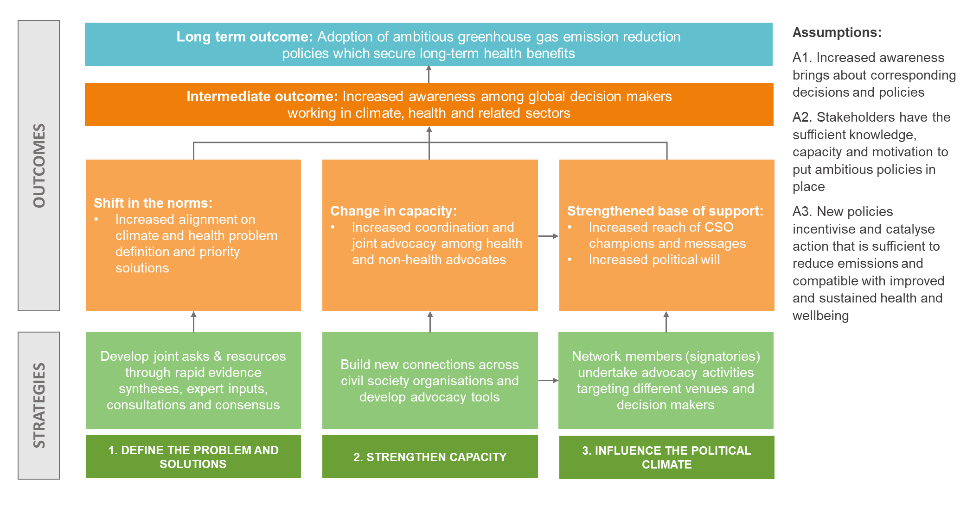
Adapted from: Pathways for change: 10 Theories to Inform Advocacy and Policy Change Efforts. www.evaluationinnovation.org
- RFP scope and objectives
Over the following year, we want to evaluate our advocacy efforts, assessing both the engagement of coalition members and its success in influencing the climate and health agenda. This evaluation is intended to provide valuable evidence to shape a new major challenge area in climate and health while improving our effectiveness in policy engagement in this space.
We want this evaluation to assess the relevance and effectiveness of the Climate and Health Coalition over the course of 2021 in three areas:
- Relevance
  - Is the coalition relevant to the needs and priorities of coalition members?
  - Is the coalition enabling members to deliver something larger than the sum of its parts? If yes, how? If not, what could have been done differently?
  - Is the coalition and resulting advocacy relevant to the needs and gaps in climate and health policy and decision making?
- Effectiveness and impact
  - Has the coalition been effective in achieving its intended outcomes and what is the likelihood it will contribute to long term impact?
  - Has the coalition brought unique or significant added value to raising awareness of the link between climate and health, for whom and in what ways?
  - To what extent do the coalition’s ways of working, structures, stakeholders, and other features support or detract from the achievement of its outcomes?
  - How do coalition members view Wellcome and Wellcome’s role in this process; how has involvement affected the perception of Wellcome?
- Future of the coalition
  - If the coalition continues to engage in and support global advocacy on climate and health in the future, where could it add value and how?
We anticipate a mixed-methods approach will be needed to implement this theory-based evaluation, including a combination of document review, desk research, key informant interviews, and other relevant methodologies.
Wellcome will provide the successful supplier with key documentation to guide the evaluation, including:
- Strategic proposal for the advocacy initiative
- Terms of Reference for the coalition and steering group
- Coalition workplan
- Governance
The successful supplier will be accountable to the Wellcome OPOH Evaluation Panel. Please see Section 11 for further detail.
- Deliverables
- Inception report, to include:
- An evaluation matrix, outlining the evaluation questions and sub questions (scope) alongside evaluation criteria, the evidence needed to answer them, sources of information and sampling approach as needed
- Interview topic guides and other evaluation instruments as needed
- Approach for collecting, managing, analysing and reporting data and relevant quality standards
- Roles and responsibilities
- Limitations
- Communications plan for project duration
- Updated timeline for key milestones

- Baseline report which focuses on the perceptions of coalition steering group members (and key Wellcome staff), including:
- An overview of the awareness and integration of the health and climate agenda among policymakers attending the target international processes
- The extent to which civil society organisations currently advocate for integrated action on climate and health and partner with others outside of their sector(s) - with a focus on identifying gaps and opportunities for strategic partnership formation
- The expectations of coalition steering group members

- Final report, by evaluation question/dimension and using evaluation criteria, with an executive summary, methodology and limitations section as well as relevant annexes. This will be delivered in two stages:
- A draft final report, shared with Wellcome in advance of the end date to allow Wellcome staff time to discuss feedback, raise questions, and make recommendations for further improvement.
- A final report, a clean and final copy.
- RFP Documents
Below lists the documents provided to suppliers to support their response to this RFP;
Document #1 – Supplier Questions
This document is to be used in accordance with the Timetable (as set out below, in Section 6 of this RFP) and is an opportunity for suppliers to ask the evaluation panel questions about the RFP process and the project in general to support their response.
All responses received within the timescales set out within the Timetable will be anonymised and shared with all suppliers within the process.
This document is for completion by suppliers.

Document #2a - Contractual Agreement
This document represents the draft contractual agreement which is to be used with the successful supplier from this RFP exercise.
This document is for information only.
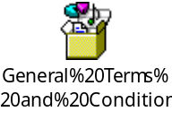
Document #2b – Contract Feedback Sheet
This document allows suppliers to provide a response to the proposed contractual agreement (Document #2a) specifically referencing any clauses which they desire to amend.
This document is for completion by suppliers. This is your opportunity to provide feedback on the contract at the appropriate point in the timetable, as part of your RFP response. The evaluation panel will then provide their responses to any supplier contract feedback submitted.

Document #3 – Third Party Security Risk Assessment
This form is used to assess how you as a supplier manage and protect data.
This form is for completion by the supplier.
TPSRA Form
Suppliers are asked to thoroughly review and reference these documents within their response accompanied by any further information provided within the RFP exercise.
- Response Format
Written Proposal
Suppliers are required to submit a written proposal which details to Wellcome the following requirements:
- A brief overview of your organisation or evaluation team, including your track record and expertise in evaluating research programmes (see Section 12 for requirements) (max 350 words). Please include as annexes:
  - PDFs or website links with examples of evaluation reports delivered.
  - Details of your team roster with one-page CV for each member
- Your proposed approach to the evaluation (max 5 pages)
Suppliers are asked to reference “Section 2: Scope and Objectives” and “Section 4: Deliverables” in providing their written proposal.
Additional documents
Suppliers are also required to submit the following two annexes to their written proposal:
- A cost proposal in Excel format which details and justifies the proposed costs, up to a maximum of £60,000. This should include details of the hourly rate and number of hours to be contributed by each member of the evaluation team.
- 2 references (inclusive of contact name, organisation, brief overview of work provided, email & telephone) who Wellcome can contact as part of this RFP process
Shortlisted suppliers may also be asked to provide two samples of previous written work for similar projects. These are not required for the initial submission.
Suppliers’ responses will be assessed using a scale which includes the following criteria:
- Evaluation experience;
- Thematic expertise;
- The strength of the proposed approach to this evaluation, including an understanding of the central aims and purpose of the project, and selection of appropriate methodology;
- The justification and value for money for the proposed costs;
- Evidence received from the 2 references.
We will work collaboratively with the appointed supplier to refine the approach at the inception stage of the process (see timetable below).

- Timetable
The timelines for this RFP exercise, including deadlines for suppliers, are detailed below:
# | Activities & Deliverables | Responsibility | Deadline (2021)
1 | RFP issued to suppliers | Wellcome | 5 February
2 | Intention to Respond to RFP & submission of Document #1 to the Wellcome contact | Supplier | 11 February
3 | Response to Document #1 returned to Suppliers | Wellcome | 15 February
4 | Full response to Written Proposal along with Annexes (as outlined in Section 5) and Documents #2b and #3 | Supplier | 19 February
5 | Interviews for shortlisted candidates | Wellcome | 1 March
6 | Notification of Contract Award | Wellcome | 4 March
7 | Contract Negotiation | Both | 5 March
8 | Contract Start Date; initial meeting to discuss inception report | Both | 5 March
9 | Inception report draft | Supplier | 12 March
10 | Wellcome respond to draft inception report | Wellcome | 15 March
11 | Final inception report, with any amendments | Supplier | 18 March
12 | Baseline report submitted | Supplier | 14 May
13 | Wellcome response to baseline report | Wellcome | 25 May
14 | Endline report submitted | Supplier | 10 Dec
15 | Wellcome response to endline report | Wellcome | 17 Dec
16 | Final endline report submitted | Supplier | 7 Jan 2022
17 | Presentation and discussion of final endline report | Both | 14 Jan 2022
The following section explains in further detail the activities set out within the timetable up to the commencement of the contract:
#1 – RFP Issue to suppliers
The RFP document will be circulated to the Supplier representatives for review.
#2 – Intention to Respond to RFP & submission of Document #1
Suppliers will indicate their intention to respond to the RFP formally to the Wellcome contact and submit their questions within Document #1.
#3 – Response to Document #1
Wellcome will answer all questions submitted by all suppliers, anonymise any elements which require confidentiality and share all answered questions with all Suppliers.
#4 – Full Response
Suppliers will submit in line with this RFP the following documents;
- Written Proposal including annexes
- Document #2b
- Document #3
#5 – Interviews
Shortlisted suppliers will be invited for a face to face or online interview.
#6 - Notification of Contract Award
Wellcome will notify Suppliers of their outcome from the RFP process and agree next steps.
#7 – Contract Negotiation
This stage sees the contract negotiated and finalised.
#8 – Contract Start Date
This stage sees the contract commence.
- Non-Disclosure and Confidentiality
Prospective suppliers should be aware that inappropriate publicity could have a serious effect upon Wellcome’s business. The information contained within this document or subsequently made available to prospective suppliers is deemed confidential and must not be disclosed without the prior written consent of Wellcome unless required by law.
- Independent Proposal
By submission of a proposal, prospective suppliers warrant that the prices in the proposal have been arrived at independently, without consultation, communication, agreement or understanding for the purpose of restricting competition, as to any matter relating to such prices, with any other potential supplier or with any competitor.
- Costs Incurred by Prospective Suppliers
It should be noted that this document relates to a Request for Proposal only and not a firm commitment from Wellcome to enter into a contractual agreement. In addition, Wellcome will not be held responsible for any costs associated with the production of a response to this Request for Proposal.
- Wellcome Contact Details and Delivery
The main point of contact within this RFP exercise for all communications is indicated below:
Name: Alison Doig
Email: a.doig@wellcome.ac.uk
The Evaluation Panel will be responsible for reviewing and approving deliverables, providing feedback and support to consultants throughout the process as needed. The Panel will consist of the following individuals in addition to those listed above:
- Lydia Greenaway – Evaluation Lead, Strategy and Data Insights
- Jessica Romo – Evaluation Manager, Strategy and Data Insights
- Madeleine Thomson – Interim Head, Our Planet Our Health
- Jose Siri – Senior Science Lead, Our Planet Our Health
- Will Tucker – Communications Lead – Priority Areas, Corporate Affairs
- Modi Mwatsama – Senior Science Lead, Our Planet Our Health
- Supplier specification
Required experience and expertise of the primary researcher and report author:
- Strong experience and track record carrying out policy and advocacy evaluations
- Experience conducting theory-based or complex evaluations
- Experience and expertise in qualitative data collection and analysis
- Experience using OECD-DAC evaluation criteria or other internationally recognised frameworks
Desirable:
- Experience in climate, health and/or related sectors
- Experience carrying out evaluations for large foundations and/or research funders

