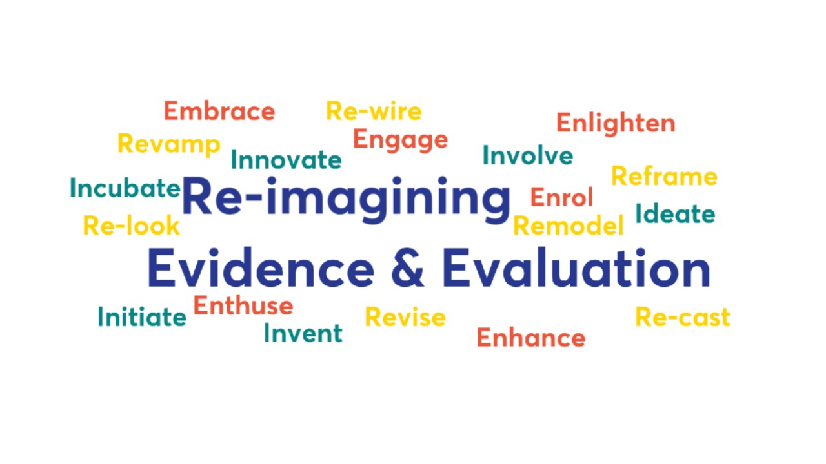


UK Evaluation Society Conference

May 24 - 26 2022
Online + in-person,
One BirdCage Walk. Westminster, London

Theme:
'Re-Imagining Evidence and Evaluation - Politics, Contexts, Challenges'

Fantastic opportunity to gain a wealth of insights from a wide variety of those working in the field of evaluation. Hybrid format 2-days online and 1-day in-person enables you to engage in the way which suits you ! Recordings of presentations will be made accessible for Delegates

Register now on UK Evaluation Society webpage
https://www.evaluation.org.uk/event/uk-evaluation-society-annual-conference-2022-2/

Tuesday and Wednesday MAY 24 + 25
Online (Zoom)
Around 50 sessions of evaluation experience, skills, methods, case studies, discussions
From practitioners, researchers, government departments, academics, policymakers, evaluators, commissioners......

Thursday MAY 26
In-person, One Birdcage Walk, Westminster, London (+ livestream)
Doors open 0830
Programme 0900 - 1730

Thursday Programme

Round Table Exchange - Evaluative Practice Fit for the Future
Is evaluation ready for the Data Revolution ?
Dr Jos Vaessen, Independent Evaluation Group, World Bank
Dr Noshua Watson, Interwoven, Social Impact analytics, London
Mette Bastholm Jensen, Deputy Director, XCEPT, Chemonics
Moderator: Professor Murray Saunders, University of Lancaster

In Conversation with Baroness Helena Kennedy, QC
Professor Eliot Stern, acknowledged thought leader in Evaluation, discusses perspectives on evidence and evaluative practice from the respective professiona, and Baroness Kennedy’s particular and extensive experience.

Meet the Author
Ethics for Evaluation - Beyond ‘do no harm’ to ’tackling bad’ and ‘doing good’
Rob D Van den Berg, Visiting Professor King’s College London
Dr Inga-Lill Aronsson - University of Uppsala
Hur Hassnain - Evaluation Support Unit INTPA, EU

Transforming Evaluation in Government
Panel moderated by Dr Tim Chadborn, UK Dept Health and Social Care
Ruth Kelly, Chief Analyst, UK National Audit Office
Jennifer Rowland, Deputy Director, HMT
Becca Briggs, Office for National Statistics

Learning the Art of Evaluation - Now and in the Future
Discussion led by George Parry-Crooke, Professor, London Metropolitan University
Nigel Simister, Associate, INTRAC
Sally Cupitt, Evaluation and Impact Consultant, UK

KEYNOTE
Professor Ruth Boaden
Independent Adviser on Evaluation to Greater Manchester Health and Social Care Partnership
Honorary Professor, Alliance Manchester Business School

www.evaluation.org.uk

Further Information contact : hello@evaluation.org.uk

Conference Team
UK Evaluation Society

