ILO/EVAL is looking for an evaluator to conduct the independent final evaluation of the project AU-EU Skills for Youth Employability Programme, Component 2: ‘Skills Initiative for Africa’ (Output 3 - SIFA – Skills Anticipation Project) RAF/19/01/DEU to take place in July-September 2022.
The final evaluation should take about 31 working days for the consultant.
Application deadline: 1 July 2022
Type of contract: External Collaboration Contract or Service contract
Profile of the consultant(s):
- University Degree in in social development or economic or related subject or equivalent.
- Experience of minimum 7 years in theory of change-based project /program evaluation, including, as much as possible evaluation of skills development field projects and programs in Africa, gender and results base management elements.
- Good knowledge and understanding of the skills development, labor market and skills anticipation systems and approaches will be an asset.
- Knowledge of ILO’s roles and mandate and its tripartite structure as well as UN evaluation norms and its programming.
- Extensive knowledge of, and experience in applying, qualitative and quantitative research methodologies.
- Excellent analytical skills and communication skills.
- Demonstrated excellent report writing and oral skills in English.
For further details about the evaluation, please see the ToR below.
Candidates intending to submit an expression of interest must supply the following information:
- A description of how the candidate’s skills, qualifications and experience are relevant to the required qualifications of this assignment (maximum 2 pages).
- A list of previous evaluations that are relevant to the context and subject matter of this assignment, indicating the role played by then consultant(s) applying (they can be highlighted in the CV).
- A statement confirming their availability to conduct this assignment, and the daily professional fee expressed in US dollars.
- A copy of the candidate’s curriculum vitae.
- A statement confirming that the candidates have no previous involvement in the implementation and delivery of the project to be evaluated or a personal relationship with any ILO Officials who are engaged in the project.
- The names of two referees (including phone and email) who can be contacted.
- Two reports in which the evaluator team leader has been the sole evaluator or the team leader.
The deadline to submit expression of interest for undertaking the evaluation is 1 July 2022.
Please send an e-mail with the subject header “Evaluation of SIFA project” to the Evaluation Manager Ricardo Furman (furman@ilo.org) and copying Pacome Dessero (dessero@ilo.org).
Many thanks.
Best,
Ricardo


____________________________
International Labour Organization

TERMS OF REFERENCE (TOR)
INDEPENDENT FINAL EVALUATION

Version 6 June 2022

 | AU-EU Skills for Youth Employability Programme  Component 2: ‘Skills Initiative for Africa’  (Output 3 - SIFA – Skills Anticipation Project)
  Project Title:
Project Code | RAF/19/01/DEU
Administrative Unit | ILPO Country Office Pretoria
Donor | Germany – GIZ
Budget | USD 3,683,082
Implementation period | 18 September 2019- 30 September 2022
ILO Technical Units | SKILLS
Type of evaluation | Independent Final Evaluation
Date of the evaluation | September-November 2022
Evaluation Manager | Ricardo Furman

- Background

The skills development landscape in most African Countries typically consists of public and private providers and is often highly fragmented and poorly coordinated. Skills development programmes on the other hand normally lack demand-orientation and quality and neither meet labour market demand for skills nor social demand for accessible skills development that can lead to better employability. The lack of accepted labour market relevant skills development outcomes and provision standards means that comparability and quality assurance of programmes and certificates is often not possible. This has a negative impact on the reputation of skills development and hinders articulation in the education and training system as well as labour mobility. As a result, a shortage of skilled workers and at the same time high unemployment, even among graduates from skills development programmes is a very common phenomenon in most African countries.

This coupled with tensions between a rapidly growing young population and the relatively low pace of job creation are cause for more determined action and partnerships for more informed skills development approaches and more and quality jobs for young African. The high number of youths not in education employment or training, and the estimated 95 million of youth in sub-Saharan Africa who are uneducated, unemployed or engaged in precarious jobs represent a serious challenge for African decision makers and practitioners.

On the other hand, globalization offers opportunities to accelerate economic development, increasing output and incomes, and to diversify in economic sectors offering opportunities for growth in productive and higher value-added employment. It also brings challenges where investment in human capital becomes vital for workers and enterprises to adjust to change and remain competitive in global markets. Skills development is also instrumental for access to productive employment and in ensuring that no one is left behind. The International Labour Conference concluded in 2008 that connecting skills development to broader growth, employment and development strategies requires that “governments, working with the social partners, build policy coherence in linking education and skills development to today’s labour markets and to the technology, investment, trade and macroeconomic policies that generate future employment growth”.

The tripartite representation of International Labour Organization (ILO) agrees that countries that have succeeded in linking skills to gains in productivity, employment and development have targeted skills development policy towards three main objectives:
• matching supply to current demand for skills.
• helping workers and enterprises adjust to change.
• building and sustaining competencies for future labour market needs.

1.1 The SIFA-Skills Anticipation Project
The SIFA -Skills Anticipation Project (Component 3 of SIFA) is part of the AU-EU Skills for Youth Employability Programme (SYEP) which is part of the DCI Pan-African Programme 2018 financed from the general budget of the European Union (EU). SYEP contributes to the Skills Initiative for Africa (SIFA) of the African Union and AUDA-NEPAD. SYEP Action Document calls for a collaborative engagement with the ILO to conceive and implement relevant activities in the selected output of component 2: on skills anticipation and forecasting, as integral part of labour market information systems (LMIS). The project conducted activities in the following countries

# | Country | # | Country
1 | Cameroun | 7 | Namibia
2 | Ethiopia, | 8 | Nigeria
3 | Eswatini * | 9 | South Africa
4 | Gabon * | 10 | Tanzania
5 | Ghana* | 11 | Zambia *
6 | Kenya | 12 | Zimbabwe *

Note: * Core countries with direct in-country work, others have participated in multi-country project training only.

1.2 Project Objectives and Expected Outcomes
The component 2 of the AU-EU Skills for Youth Employability Programme focuses on improving the conditions for a continental framework for employment-oriented skills development.

The overall objective of SYEP is to improve employment prospects of young Africans and through strengthened, capacities, Pan-African platforms for dialogue and sharing of best practices. Under the overall Programme log frame, the ILO, is responsible for implementation of Output 3 on enhancing capacities of AUC, NEPAD, RECs and national authorities for labour market forecasts and skills need anticipation systems. The ILO supported component was also expected to contribute to implementation of the following SYEP outputs.
- Output 1: Stronger continental (regional) dialogue platforms and/or formats for learning, innovation, and cooperation are established.
- Output 2: Knowledgebase and inventory of best practices and TVET products is established
- Output 6: Capacities of AUC and NEPAD to steer the continental and regional skills development and youth employment agenda are strengthened.

The indicators of achievement for the skills anticipation project component are as follows:

Indicator 3.1: Number of representatives of RECs, AUDA-NEPAD, AUC and national institutions) participating in task-related training on labour market forecasts and skills needs anticipation whose skills in these domains have improved and benefitted those Organisations (disaggregated by country)

Indicator 3.2: Number of countries having developed a skills inventory to analyse skills demand and supply built on project common framework

Output 3 on skills anticipation Component also contributes to the achievement of the overall SIFA outcome under outcome indicator 2: on number of countries that have applied/implemented skills needs anticipation approaches during project implementation time with a target of two Countries.

You can find additional information at: https://www.ilo.org/DevelopmentCooperationDashboard/#arru102

1.3 Project implementation Strategy

The Skills Anticipation Component aims a common understanding at continental and national levels about of the strategic role that skills anticipation plays in ensuring skills development that is more responsive to labour market needs and at building capacity for more systematic identification and anticipation of current and future skills needs as an integral part of national labour market information systems (LMIS). This is with the view to minimize the gaps between skills demand and skills supply and that ensure more effective matching of skills supply to skills demand in the labour markets of targeted AU Member States.

The focuses on enhancing understating and appreciation of skills capacity at African Union and AUDA level and at d member states level with more concentrated action in specific countries. Activities include training and capacity building of bodies and networks in charge of LMI and skills development systems and practical analyses of skills demand and supply. National statistical bodies, public employment services, labour and skills development authorities, relevant research centres and social partners are the key stakeholders.

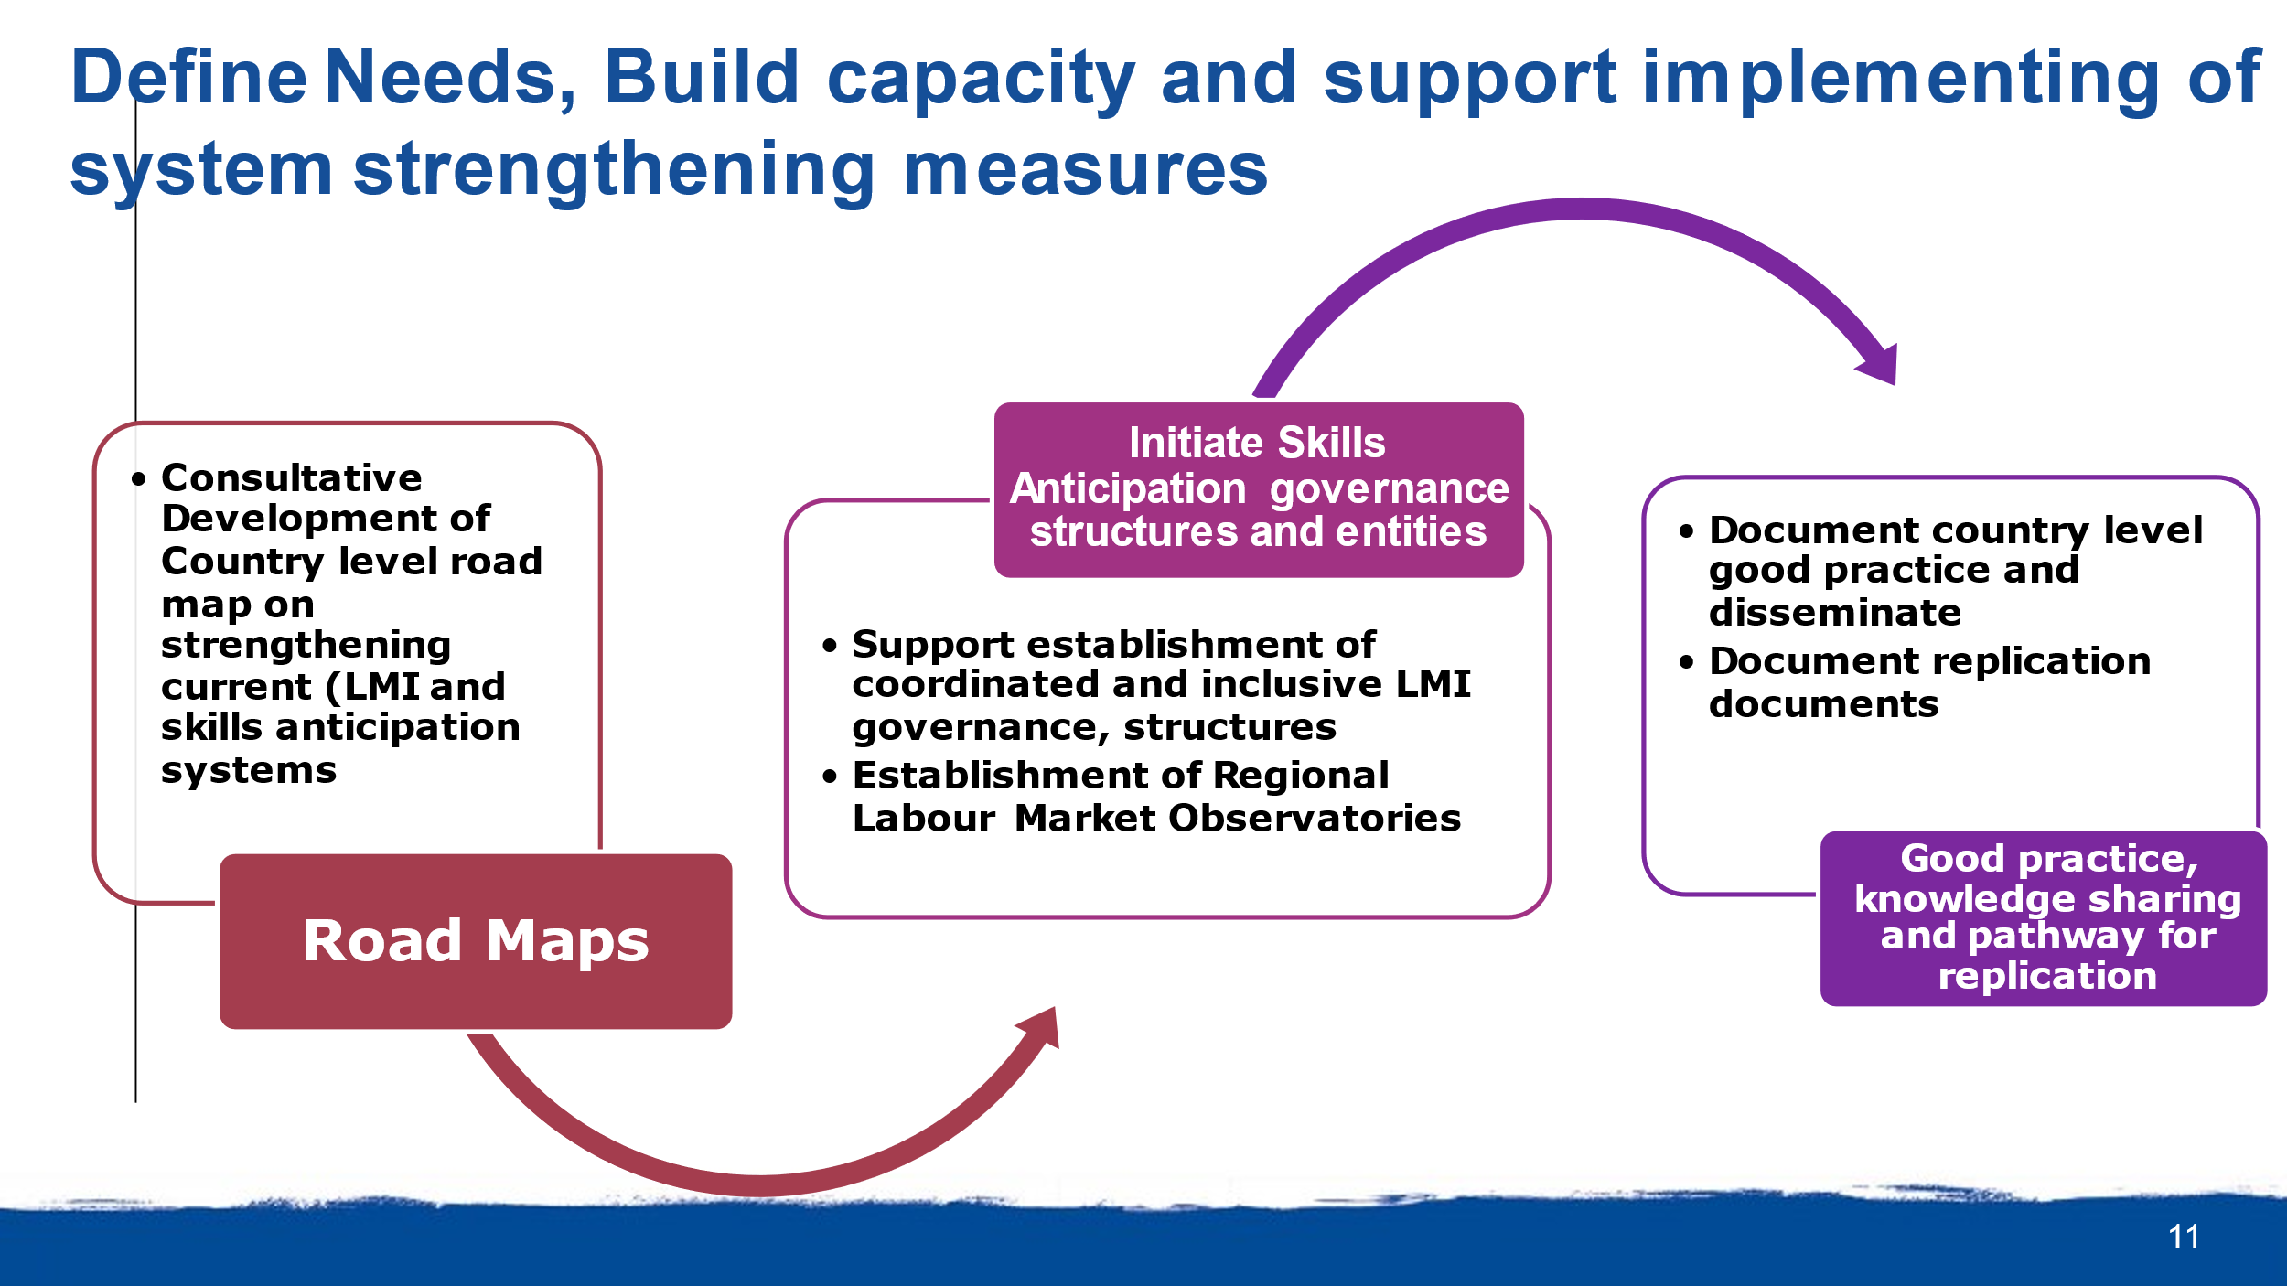
The Project applies a two-step implementation strategy in which the first step involved mapping of data sources/providers, review current practices, capacities and institutional arrangements for labour market information and skills anticipation, identifying existing system weaknesses and providing concrete recommendations for strengthening of current systems and structures.

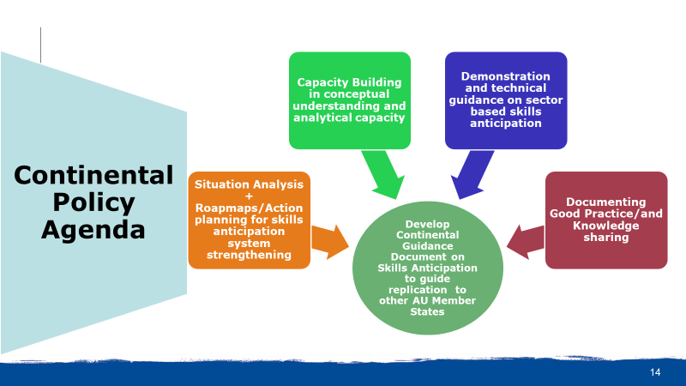
The second step involves synthesizing the lessons and good practices from the implementation of Project interventions and consolidating these into a Continental Skills Anticipation Guidance Note which can assist with the replication of skills anticipation strengthening and effective integration into national labour market information systems.

1.4 Project Management Arrangements
The project is managed by a Chief Technical Adviser (CTA), based in ILO-CO Pretoria, supported by an admin and financial assistant, who is responsible for management of the skills anticipation component (reporting to the Director of the ILO Pretoria Country/DWT Office). In addition, the project has the following staff in other countries:
- National Project Coordinator and part-time admin and financial assistant in in Tanzania
- National Project Coordinator and part-time admin and financial assistant in Gabon
- National Project Officer in Zimbabwe

- Purpose, Objectives and Scope Of The Final Independent Evaluation

The main purpose of this final evaluation is to provide an independent assessment of the progress achieved during the project entire life, through analysis of relevance, effectiveness, efficiency, effectiveness, and orientation to impact of the project.

The specific objectives of the evaluation are the following:

- Assess the relevance and coherence of the project to the targeted countries’ needs, considering their national policy frameworks and those of the African Union and African Union Commission (AUDA NEPAD) and the targeted final beneficiaries and its synergy with related projects and programs in the target countries funded under any scheme.
- Identify the contributions of the project to SDGs targets, UNSDCFs, and ILO’s planning framework in the target Countries.
- Assess the extent to which the project has achieved its stated objectives and results, identifying the supporting factors, and the constraints that have led to it , including strategies and implementation modalities chosen, partnership arrangements and unexpected positive and negative results of the project
- Assess the implementation efficiency of the Project regarding the financial dimension and institutional management arrangements
- Analyse the project achieved and potential impact at national and institutional and the extent to which the project outcomes will be sustainable.
- Identify lessons learned and potential good practices, especially regarding models of interventions that can be applied further.
- Provide recommendations to project stakeholders to promote sustainability and support further development of the project outcomes

- Evaluation Background

The ILO considers independent evaluations as an integral part of the implementation of technical cooperation project activities. Evaluations for ILO implemented activities are managed by ILO certified evaluation managers and implemented by independent external evaluators. The evaluations are for the purpose of accountability, learning, planning, and building knowledge and are conducted in the context of criteria and approaches for international development assistance as established by a) the OECD/DAC Evaluation Quality Standard; and b) the UNEG Code of Conduct for Evaluation in the UN System.

This independent evaluation will follow the ILO policy guidelines for results-based evaluation; and the ILO EVAL Policy Guidelines Checklist 3 “Preparing the inception report”; Checklist 4 “Validating methodologies”; Checklist 5 “Preparing the evaluation report” and Guidance Note 3.2: Adapting evaluation methods to the ILO’s normative and tripartite mandate.

These ToRs under and the ILO Evaluation policies and guidelines define the overall scope of this evaluation. Recommendations, emerging from the evaluation, should be strongly linked to the findings of the evaluation and should provide clear guidance to the different stakeholders on how the recommendations can be addressed.

- SCOPE OF THE EVALUATION

This final independent evaluation will cover the period September 2019 to July 2022. The evaluation will cover all the planned outputs and outcomes under the project, with particular attention to synergies between the components and its contributions policies and strategies of the target Organizations and Countries.

The evaluation will analyze how the project addressed its main issue, raising awareness of the critical role that skills anticipation plays in ensuring response skills development and establishing skills anticipation as an integral part of labour market information systems in member states. The evaluation should also analyze how the cross-cutting issues of non-discrimination, social dialogue and tripartism, international labour standards, and just transition to environmental sustainability have been addressed by the Project.

The evaluation should provide mainly understanding of how and why the project has obtained or not the specific results from output to potential impacts.

- REVIEW CRITERIA AND KEY EVALUATION QUESTIONS

  - Review criteria
The evaluation should address the overall ILO evaluation concerns regarding to relevance, coherence, effectiveness, efficiency, sustainability and impact of the Project results as defined in the ILO Policy Guidelines for results-based evaluation (2017). (https://www.ilo.org/wcmsp5/groups/public/---ed_mas/-- eval/documents/publication/wcms_571339.pdf)

At the inception phase the evaluator should integrate in the evaluation questions the ILO cross-cutting themes mentioned in section 4 above.

  - Key Evaluation Questions
Under each of the evaluation concerns, the evaluator shall examine the following key issues:

- Relevance, coherence, and strategic fit,
- Is the project coherent with the AUC, AUDA-NEPAD and National governments objectives, National Development Frameworks, and stakeholders’ needs, and does it support the outcomes outlined in the SIFA Project logframe, the ILO Country Programme Outcomes well as the Countries’ UNSDCFs and SDGs?
- How does the project complement and fit with other ongoing AUC, AUDA-NEAD and ILO programmes and projects in the target countries?
- What links have been established with other activities of the UN, GIZ and other cooperating partners operating in the areas of skills anticipation labour market information and employment.
- Has the project been able to leverage the ILO comparative advantages (including tripartism, international labour standards social dialogue etc.)?
- How has the project addressed the needs of the ultimate beneficiaries including specifically men and women and persons living with disabilities? Has there been changes in these needs during the life of the project?
- Has the project created good relationship and cooperation with relevant continental, regional and national level institutions, and other relevant stakeholders?

- Validity of Intervention Design
- Did the project address the major issues relating to skills anticipation and responsive skills development in the target organization and member states?
- Is the project Theory of change comprehensive, integrating external factors and is based on systemic analysis?
- Was the project design and implementation realistic (in terms of expected outputs, outcome, and impact) given the time and resources available, including performance and its M&E system, knowledge sharing and communication strategy?
- To what extent did the project integrate crosscutting themes in the design and implementation (tripartism and social dialogue, gender and non-discrimination, international labor standards and fair transition on environment?

- Effectiveness:
- To what extent has the project achieved the overall project objectives/outcomes?
- Have unexpected positive or negative results been identified, how have these contributed to project planned results achieved?
- Has the project addressed strategic needs of women, people with incapacities and other vulnerable groups?
- Have the project results integrated ILO constituents and a fair transition to environment?
- Assess how contextual and institutional risks and positive external to the project factors have influenced the project results?
- Has the knowledge sharing and communication strategy been effective in raising the profile of the project among Project partners, the donor, within target countries and among the cooperating partners?
- To what extent the COVID-19 Pandemic influenced project results and effectiveness and how the project addressed this influence?
- Did the (adapted) intervention model(s) used in the project suggest an intervention model for similar crisis response?
- Has the monitoring and evaluation system results-based and facilitate a project adaptive management?

- Efficiency of resource use (including management arrangements)
- Were the resources (financial, human, technical support, etc.) strategically allocated to achieve the project outputs and specially outcomes? If not, why?
- To what extent have been the disbursements and project expenditures in line with expected budgetary plans? Has the rate of spending been acceptable?
- Has the project received adequate administrative, technical and - if needed – policy and technical support from the ILO office and specialists in the field (Decent Work Team Cairo, Regional office, the responsible technical units (SKILLS) in HQ, and from ILO International Training Center?
- Has the management and governance structure put in place worked strategically with all key stakeholders and partners, including ILO Units and the donor to achieve project goals and objectives?
- To what extent did the project leverage partnerships (with constituents, with AU and AUDA-NEPAD, national institutions, and other UN/development agencies) that enhanced the project’s relevance and contribution to the Project targets and indicators? (Explicitly or implicitly)

- Impact orientation and sustainability
- Did the project contribute to expanding the knowledge base on skills anticipation and to building evidence to guide skills development?
- What level of influence did the project have on raising awareness about the importance of skills anticipation, its integration into national labour market information systems and its contribution to the development of responsive skills policies, strategies and practices at continental and national levels?
- Which project-supported tools were institutionalized, or have the potential to be institutionalized and replicated by Project partners, the AU, AUDA-NEPAD and by national governments or other external organizations?
- To what extent are the results of the project interventions likely to have a long term, sustainable positive contribution in the target countries with considerations for women and people with disabilities (explicitly or implicitly)?
- Did the project develop and implement an exit strategy?
- How was the sustainability approach of the project been affected by the Covid19 situation?
- How likely is it that the project’s strategic orientation will be used in the future, to systemically respond to the multifaceted crisis like the one induced by COVID-19?
- EVALUATION METHODOLOGY

The independent final evaluation should comply with evaluation norms and standards, and follow ethical safeguards, specified in ILO’s evaluation procedures. The ILO adheres to the United Nations Evaluation Group (UNEG) evaluation norms and standards as well as to the OECD/DAC Evaluation Quality Standards. The evaluation is an independent evaluation, and the final methodology and evaluation questions will be determined by the consultant in consultation with the Evaluation Manager.

The evaluation will apply a mix methods approach, including triangulation, to increase the validity and rigor of the evaluation findings, engaging with key stakeholders of the project, as much as feasible, at all levels during the design, data collection and reporting stages.

The evaluation will take account of any COVID 19 implications and will be conducted in the context of criteria and approaches outlined in the ILO internal guide on implications of COVID-19 on evaluations in the ILO: An internal Guide on adapting to the situation (version March 25, 2020).

The evaluation will include but will not be restricted to the following methods:

- Desk review: The desk review will involve briefing interviews with the project team, donor and AUDA-NEPAD and will include review of the following information sources:
- Project documents (logframe, budget, implementation plan, etc.)
- Progress reports and outputs
- Research and studies conducted by the Project
- Project finance documents and records
- Mission reports
- All other relevant document from the project

Preliminary findings from the desk review will be used to fine-tuning the evaluation questions.

The approval of the inception report by the evaluation manager is a condition to move to the data collection phase.

- Interviews with Project stakeholders (i.e., project level, five core countries and trainees for non-core countries) through virtual and face-to-face interviews, electronic surveys and/or other means proposed at the inception phase and approved at the inception report.

The Consultant will be expected to travel to maximum four project Countries (tentatively Eswatini, Gabon, Ghana, and Zimbabwe) to review the results of project interventions and to hold interviews with key project partners and beneficiaries, plus a visit to Pretoria where the project CTA and AUDA are based (estimated; 2 full weeks plus 1-2 working days in Pretoria). The project country visits should take two working days by country.
An indicative list of persons to be interviewed will be prepared by the Project in consultation with the Evaluation Manager. The project will support closely logistically the organization of these interviews. This list of persons to be interviewed will include:
- Representative from the African Union, Department of Education, Science, Technology, and Innovation
- Representative from African Union Development Agency (NEPAD), Skills and Employment Unit
- Country level Project stakeholders from Eswatini, Gabon, Ghana, Tanzania, Zambia and Zimbabwe
- Other relevant stakeholders
- Representatives of the donor (GIZ-SIFA)
- Project team, ILO CO-Cairo,
- Project consultants
- Representatives from ILO Geneva SKILLS unit at DWT Pretoria and at HQ

At the end of the data collection process the evaluator will develop the draft report (see below deliverables for details). The draft will be subject to a methodological review by the evaluation manager and will upon the necessary adjustments will be circulated among the key stakeholders by the ILO Evaluation Manager. The evaluation manager will consolidate the stakeholders’ comments and will send them to evaluator for development of the final draft of the evaluation report. The preliminary findings to be shared with the key stakeholders. The evaluator will set the agenda for the meeting. The presentation should provide a brief review of key results for each evaluation criteria. The workshop will be technically organized by the evaluation team with the logistic support of the project.

Interpretation will be provided as needed during the data collection phase.

- A stakeholders’ workshop: A virtual stakeholder workshop involving key stakeholders will be organized, with the evaluator based in Pretoria, to facilitate validate findings of the Project evaluation. The Evaluator will present the final draft report at the validation workshop and receive final stakeholders feedback needed to close any possible data gaps and to finalize the report for final submission.

- MAIN DELIVERABLES

- An inception report: (not more than 20 pages excluding the annexes) - upon the review of available documents and an initial discussion with the project management and the donor. It will follows EVAL Checklist No 3

The inception report should:-
- Describe the conceptual framework that will be used to undertake the evaluation;
- Elaborate the methodology proposed in the TOR with changes as required;
- Set out in some detail the data required to answer the evaluation questions, data sources by specific evaluation questions, (emphasizing triangulation as much as possible) data collection methods, and purposive sampling
- Selection criteria for individuals for interviews from the available stakeholder list (as much as possible should include men and women and the final short list of key stakeholders to be interviewed and the tools to be used for interviews and discussions;
- Detail the work plan for the evaluation, indicating the phases in the evaluation, their key deliverables and milestones;
- Interview guides and other data collection tools
- Set out outline for the final evaluation report;
- Set out the agenda for the stakeholders workshop;

- First draft of Evaluation Report: A draft evaluation report following EVAL Checklists 5 and 6 (see Annex). The report in English should be no longer than 35 pages, excluding annexes and Executive summary. The draft report will be shared with all relevant stakeholders by the evaluation manager who will request for comments and feedback from stakeholders within two weeks.
The draft and final version of the Evaluation Report should follow this outline:
  - Cover page (ILO EVAL standard).
  - Table of contents
  - Acronyms
  - Executive Summary
  - Context and description of the project including reported results
  - Purpose, scope and clients of the evaluation
  - Methodology and limitations
  - Findings organized around evaluation criterion, (questions should not be answered individually but integrated under each criteria,) including a table showing output and outcome level results based on indicators and targets planned and achieved and comments on each one (that can be an annex).
  - Conclusions
  - Recommendations (i.e., for the different key stakeholders), indicating per each one priority, timeframe and level of resources required
  - Lessons learned and good practices
Annexes:
- TOR
- Evaluation matrix
- List of people interviewed
- Schedule of work
- Documents reviewed
- Lessons learned and good practices (under EVAL formats)
- Others

- Final Report: The final evaluation report incorporating all stakeholders’ inputs and approved by the ILO EVAL Department (after initial approval by the Evaluation manager/Regional evaluation officer)

- Executive summary of the Evaluation Report: prepared in line with the ILO EVAL template

- MANAGEMENT ARRANGEMENTS AND EVALUATION TIMELINES

8.1 Evaluation Manager: the evaluation will be managed by an ILO Official who has no prior involvement with the project and its activities. The evaluation manager will be responsible for coordinating all aspects of the evaluation and for ensure that the final version of the evaluation report addresses stakeholders’ comments.

8.2 Independent Evaluation Consultant
Required Qualifications
- University Degree in in social development or economic or related subject or equivalent.
- Experience of minimum 7 years in theory of change-based project /program evaluation, including, as much as possible evaluation of skills development field projects and programs in Africa, gender and results base management elements.
- Good knowledge and understanding of the skills development, labor market and skills anticipation systems and approaches will be an asset.
- Knowledge of ILO’s roles and mandate and its tripartite structure as well as UN evaluation norms and its programming.
- Extensive knowledge of, and experience in applying, qualitative and quantitative research methodologies.
- Excellent analytical skills and communication skills.
- Demonstrated excellent report writing and oral skills in English.

8.3 Evaluation Timeline

The evaluation will be conducted between September and November 2022.

List of Tasks | Responsible | No. of evaluators working days | Time line (Tentative dates to be adjusted)
Development of TORs and circulation to stakeholders for comments | Evaluation manger | 0 | 16 May-17 June
Call for EoI for evaluators | Evaluation Manager | 0 | 6-June-1 July
Selection of the consultant and contract signing | Evaluation manager | 0 | 4-22 July
Briefing with Evaluation Manger, desk review of project documents, and development and submission of the Inception report | Evaluator | 5 | 12-21 September
Feedback and approval of the inception report | Evaluation manager | 0 | 22-23 September
Data collection and stakeholder interviews | Evaluator | 14 | 26 September – 13 October
Stakeholder Validation Workshop | Evaluator (Project for logistics) | 1 | 14 October
Analysis of data collected and  preparation and submission of the draft report | Evaluator | 7 | 17-26 October
Review of the Zero Draft evaluation report | Evaluation manager | 0 | 27-28 October
Circulate draft report among key  stakeholders including the donor | Evaluation manager | 0 | 31 October -11 November
Consolidate feedback for sharing with the evaluator | Evaluation manager | 0 | 14-16 November
Incorporate stakeholder Feedback and submit final report | Evaluator | 2 | 17-18 November
Review for approval by Evaluation Manager and final approval by EVAL | Evaluation manager and EVAL | 0 | 21-26 November
Total days |  | 31

8.4 Budget
A budget under the full control of the evaluation manager will cover:
For the evaluator team:
- Fees for the evaluator for 31 days
- DSA and travel as per ILO regulations

For the evaluation exercise as a whole:
- Stakeholders’ workshop
- Interpretation for the consultant interviews as needed
- Any other miscellaneous costs

ANNEXE

ILO Policy Guidelines for evaluation: Principles, rationale, planning and managing for evaluations, 3rd ed.
http://www.ilo.ch/eval/Evaluationpolicy/WCMS_571339/lang--en/index.htm

Code of conduct form (To be signed by the evaluators)
http://www.ilo.org/eval/Evaluationguidance/WCMS_206205/lang--en/index.htm

Checklist No. 3: Writing the inception report
http://www.ilo.org/eval/Evaluationguidance/WCMS_165972/lang--en/index.htm

Checklist 5: preparing the evaluation report
http://www.ilo.org/eval/Evaluationguidance/WCMS_165967/lang--en/index.htm

Checklist 6: rating the quality of evaluation report
http://www.ilo.org/eval/Evaluationguidance/WCMS_165968/lang--en/index.htm

Template for lessons learnt and Emerging Good Practices
http://www.ilo.org/eval/Evaluationguidance/WCMS_206158/lang--en/index.htm
http://www.ilo.org/eval/Evaluationguidance/WCMS_206159/lang--en/index.htm

Guidance note 7: Stakeholders participation in the ILO evaluation
https://www.ilo.org/global/docs/WCMS_165982/lang--en/index.htm

Guidance note 4: Integrating gender equality in the monitoring and evaluation of projects
http://www.ilo.org/eval/Evaluationguidance/WCMS_165986/lang--en/index.htm

Guidance Note 3.2 Adapting evaluation methods to the ILO’s normative and tripartite mandate
https://www.ilo.org/wcmsp5/groups/public/---ed_mas/---eval/documents/publication/wcms_746717.pdf

Template for evaluation title page
http://www.ilo.org/eval/Evaluationguidance/WCMS_166357/lang--en/index.htm

Template for evaluation summary
http://www.ilo.org/legacy/english/edmas/eval/template-summary-en.doc

UNEG Ethical Guidelines for Evaluation
http://www.unevaluation.org/document/download/548

