EES 2022 Annual General Meeting
Friday 2 December, 2022
Via Videoconference
Time: 17:00 – 18:00 CET

MINUTES of the General Meeting (GM) of European Evaluation Society, an association, having its corporate seat in ’s-Gravenhage, and offices at Johannes Vermeerplein 11, 1071 DV Amsterdam, registered with the Trade Register of the ’s-Gravenhage Chamber of Commerce under number 40413697, hereinafter to be referred to as the Association or the EES, held via videoconference on 2 December 2022.
The Meeting was chaired by Tom Ling, President of the EES.
- Welcome

The Chairman opened the Meeting and declared:

- that this is a General Meeting held by virtual electronic means, as per the EES‘ Statutes, Art.16, paragraph 1;
- that in the notice to convene this meeting all issues to be acted upon have been stated, in particularly the information on annual report 2022, EES finances and 2021 audit report.
- The audience can ask questions via the chat box during presentations and the presenter will respond at the end of their topic.

The Chairman introduced other presenters: Secretary General – Taruna Gupta, Treasurer – Oto Potluka, Vice President – May Pettigrew, and Lea Corsetti, Communication and Administration Manager.

The Chairman extended a warm welcome to all EES Members participating in the AGM, it was very pleasing and heartening to see 50+ participants online from all parts of Europe. Participants were encouraged to put questions and thoughts in the chat which would be constantly monitored, and could be addressed at relevant points during the presentation.

- Approval of the General Meeting Minutes 2021

The Secretary-General presented the minutes from the previous Annual General Meeting, which took place on 7 December 2020 via virtual means and asked for comments.

- The minutes were unanimously approved by the 2022 Annual General Meeting.

- President´s Annual Report: Main activities 2021

The Chairman presented the activities and highlights of the EES in 2021:

- EES held a very successful Conference – the average score being 4.7/6 (259 responses)

- At the 2-day pre-conference PDWs, there were 14 workshops with 205 participants. 72% found the PDW met their learning objectives well and were overall very satisfied.

- There were 682 delegates at the 3-day conference, with 14 parallel strands and 280 sessions! There was indeed a really positive dynamic at the conference, and the Chairman sensed that delegates were really delighted to be able to meet colleagues face-to-face.

- Some key lessons learned as follows:

- Future conferences should hold fewer overall and parallel sessions, and more opportunities to meet outside formal sessions
- The venue for the conference should have bigger rooms – room dividers were installed after EES had viewed the rooms!
- The venue should take the appropriate health and safety measures, i.e. COVID-19 precautions
- Better keynote gender balance (one of the female keynotes was unable to attend, but EES did make efforts towards this)
- Improved functionality of the conference app, acknowledging it already functioned relatively well
- More active engagement of Young Emerging Evaluators and persons from the Global South

- EES have successfully switched to a calendar based membership on the JustGo platform, and is moving to full GDPR compliance.

- The second annual membership survey was implemented, and it should be noted that most members who responded to the survey were happy with their membership.
The main interactions with the EES included: Accessing the Evaluation journal; Reading the monthly newsletter; attending the September 2021 Online Conference and/or PDWs; checking the website for information on upcoming events, training, and/or job opportunities; submitting an abstract for the upcoming EES biennial Conference in June 2022 and read at least one blog article

- EES’s purpose is to serve its members, and indeed income comes from Members and conferences. It is important that EES should be achieving and sustaining membership. Membership currently stands at 972 :

730 Individual members
3 Lifetime Members
15 Student Members
44 Institutional Lead Members
180 Institutional Individual Members

The majority of members are in the 40-50 age category, with few extending upwards! Ideally, it would be great to see more younger members.

- The President shared with participants a chart which identified the geographical spread of members, which shows that although Europe is the EES centre of gravity, there are significant numbers from North America, North Africa, South America and Oceania. It is good to see that EES is extending its influence and drawing on the expertise and wisdom of people from Africa and North America, and beyond.

- TWG Update – as is expected, some thrive more than others each year; however, the TWGs are going well.

TWG1 Gender and Evaluation – published a blog on International Women’s Day in March, which was well received; a few more members joined following the release of the April newsletter, and they hosted four sessions at the EES Conference in Copenhagen.

TWG 2 Evaluating Sustainable Development – Planning to host a spring meeting. One of the topics in discussion will be the interrelationship between state and non-state activities for SDGs and the dilemma between long-term and short-term sustainability evaluations, as discussed during the EES Conference in 2022.

TWG 3 Private Sector Evaluation – Collaborated on several EvalEdge podcast episodes on blended finance (IFC); private capital mobilization (IEG); evaluating private sector engagement programs (Deval – forthcoming December 2022). The membership of this group has grown, now having 67 declared members following the Conference.

TWG 4 Professionalisation of Evaluation – This TWG had been concentrating on PDWs at Conference. Sadly the leader of this group, Martha McGuire, has had to resign due to health reasons and work is underway to assign a new lead.

TWG 5 Emerging Evaluators – The yEES! Competition was very successful and 9 winners supported the 2022 Conference. Members have continued involvement in p2p+ Europe Hub.

TWG 6 Methods and Design – A TWG meeting was held during Conference : Method Integration in Complex Evaluations (10 June 2022), and 2 Methods Webinars have been held.

TWG 7 EU Policies – A joint webinar is being planned with TWG 6 to be held in February, and the group is working on a special issue on the theme of quality of life as an evaluation criterion.

It was noted that a new TWG is being set up – TWG 8 Approaches in Evaluation.

EES had previously listed TWG member names on the relevant TWG page on the website, however, in order to comply with GDPR names were removed, and members’ express permissions are being sought before publishing.

- EES were well aware that members needed to see benefits and value for their membership, and from EES’s perspective this was seen as :

Participation in TWGs
Reduced Conference fees
Reduced registration fees for PDWs
Free access to online events
Access to academic publications
Networking and visibility
Full access to all EES products and website
Opportunity to influence EES direction and policy

Tom wished to convey huge thanks to May as Vice -president this year, to Taruna, as Secretary General and Oto, as Treasurer, who had joined the Board and added a huge degree of dynamism and professionalism. The whole board had been an absolute joy to be working with. He was also very appreciative of the work of the Secretariat provided by Baytree, who were providing a fantastic service. He also wished to thank Lauren Weiss as the outgoing Administration and Communications Manager and equally welcome Lea Corsetti as the incoming Communications Manager.

Questions/Comments

Ana Luisa Guzman wished to congratulate EES for a great conference, it was great to participate, meet and learn from so many people with so much experience. She welcomed the comments about the balance of participation of women and men and moving towards equal gender opportunities, and agreed with the comments about size of rooms.

Andy Rowe was concerned that environmental sustainability needs to be a strong theme in the coming year and Tom very much confirmed that was a high priority for EES.

Burt Perrin commented that the membership data was promising but wondered how many members are just for one year as the problem in the past has been that numbers increase in a conference year but drop off in a non-conference year. Tom concurred and stated that the offer for EES members needs to be so compelling and interesting and participation enjoyable that members will stay engaged.

- Communication Manager’s Annual Report : Lea Corsetti

Lea reported that the focus had been on maintaining the programme of comms published in 2021, which had been pretty much achieved: 25 blogs, 5 podcast episodes, 12 Monthly newsletters

EES had increased its Twitter followers by around 400, now 7,302. EES has 6,444 followers on LinkedIn, and each post has an average of 1000+ impressions

Regarding EES contributing to global campaigns, plans are to contribute to the Eval4Action youth week in April 2023, especially TWG 5 Young Evaluators are preparing to engage with this initiative.

With the P2P career and Advisory hub for Emerging Evaluators, TWG 5 was a founding partner of the European hub and continues to be engaged in this initiative; there had been two p2p+ Europe sessions and 1 UNFPA career workshop.

- NESE : Report from Daniele Lamarque, Past President

It was noted that Daniele represented EES on NESE; this Advisory Board was composed of 6 members from Greece, Spain, Poland, Germany, Austria, Italy and Daniele from France (EES).

She wished to thank her EES colleagues and the secretariat for their support.

The key horizontal Principles :

- The project (funded by the IOCE and Evalpartners under the Peer-toPeer (P2P) Grants Program 2021) aimed at strengthening the co-operation among VOPEs through developing a Common Reference Framework.
- Advocating for the implementation of key horizontal principles of evaluation (equity, gender equality, social justice, partnership, good governance, innovation inclusivity, democracy, human rights, sustainable development)
- Lead by the NESE Advisory Board in 2021 through a questionnaire sent to al European VOPEs (13 responses)

Conclusions :

- The questionnaire identified limited visibility of the principles, a lack of clear commitment to be found in documents or guidelines, and limited evidence for integrating the KHPs in evaluation standards and in the professionalisation framework.
- Greater progress has been identified for principles related to issued methodological guidance documents, such as gender, inclusivity, partnership and sustainable development, in thematic evaluations.

Recommendations :

- The CRF is a Position Paper for setting the necessity and the ground for developing quality and credible evaluations, and a practical tool not only for VOPEs in Europe to ensure the sustainability of professional competencies regarding the key principles but also for NESE to undertake co-ordinated action for exchange and monitoring of progress in the field.

Other actions taken by Advisory Board :

Review of NESE Statutory role; development of NESE action plan; Organisation of a Think Tank on KHPs in EES 2022 Biennale; Representation to VOPEs Conferences (where invited); Start of a public discourse on KHPs with interested VOPEs.

Other steps were under consideration: Preparation of NESE Conference 9 Dec 2022; Present KHPs project outcomes to national events; prepare a podcast to upload to NESE/EES website; prepare a scientific paper for HES collaborative anniversary edition; running a regular biannual survey in EU VOPEs to map the as-is; Expand collaborations with other networks and disseminate the recommendations to date; disseminate the questionnaire as a common tool for benchmarking for a global survey (IOCE); Run the GA and the elections for the next Advisory Board February 2023.

- Treasurers Report – Finances/Annual Accounts 2021, 20022, Oto Potluka, Treasurer

Oto shared a slide showing the Profit and Loss Trend for 2010-2022, the net amount for 2022 will remain in the black, but there are outstanding invoices to be paid.

The financial statement for 2021 and profit and loss comparison table for 2018-2022 shows the structure of the budget and what a positive impact Conference years has on EES finances.
The conference was the largest component of both income and costs for 2022!

Status of bank accounts :

EURO 206,187.88
$ 74,670.64

Questions/Comments

Sven Harten commented that the conference was much more expensive than pre-covid conferences. Oto responded that this was purely down to the location. EES had tried to negotiate lower costs with the hotel but had not been successful. A decision had already been taken that the next conference would be in a country where the costs would be cheaper.

Bojan Pavlovic enquired whether there were options to partner with commercial businesses and offer special offers and discounts etc. (such as project management tools, CRM tools, M&E tools etc.), which could increase EES visibility with the professional community and bring EES closer to such businesses.

Tom advised that there were no immediate plans, but ways of collaborating and generating income would be interesting. He suggested that Bojan email EES with a bit more information.

Oto was thanked for preparing accounts in a way which were much easier to understand than in previous years.

- A Brief Outlook for 2023, May Pettigrew, EES Vice-President

May advised members that she wished to talk through EES aspirations for the coming year; it was important that members had an opportunity to give their sense of ideal directions for EES and to collaborate on shaping the events and other programmes for 2023 and preparations for the next conference which will be underway in January.

Plans for 2023 include :

- Strengthen relationships with members and outreach to stakeholders and VOPEs, and collaborate more with the Evaluation Journal
- Collaborations with NESE/VOPEs and aim to run more face-to-face regional seminars; we hope the membership will work with EES to plan these
- EES will continue a programme of online webinars – starting in the 1st quarter of 2023 plus, there will be continued efforts on podcasts, EvalDigest and communications with membership. Any ideas for work in these areas please do let us know.
- Preparatory work on EES 2024 Conference has started – In January 2023, it is anticipated a new PCO will be contracted. Invitations for expressions of interest to find out what VOPEs, countries, members, would be keen to support the conference with regard to venue, so it is anticipated more information will be forthcoming early in 2023. EES is already working up ideas for the conference theme. begin work on sponsorship and on keynotes
- There will be a big drive to get more sponsorship. Whilst the bursary campaign has been successful EES would like to see that significantly expanded for 2024.
- Launch call for abstracts earlier than previously which will enable over a year for continuous review and acceptance of abstracts
- Strengthen support and liaise with TWGs on proposed session strands
- Encourage well-established evaluators to propose sessions involving yEES and financially disadvantaged evaluators notably from the south including sponsorship package
- Exploring various elements of live-streaming and possibly fully hybrid events depending on what can be contracted as it would be good to shift the balance and reduce the conference carbon footprint, and enable wider participation of members.

Ananda Millard highlighted that significant attention is being paid to feedback received following the last conference and it is intended to craft a conference that takes this feedback into account.

Questions/Comments

Barbara Schmidt-Abbey commented that the plans for 2023 and the upcoming 2024 conference sound great. Finding a good balance between on-site and online participation would be excellent to be more inclusive.

Bojan Pavlovic remarked great presentation! It would also be great to shift the focus to the importance of ‘Online data’ and ‘digital indicators’ because many projects are turning towards or integrating ‘digital indicators’ in their projects especially hoping to achieve an impact on knowledge, attitude and behaviour. This is something really important to keep in mind.

EES invited members to engage by inputting to a Mentimeter presentation their thoughts on “What initiatives/opportunities would you like the EES to take forward/present in 2023?”
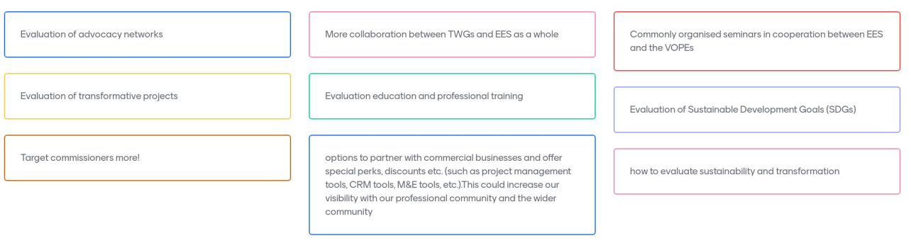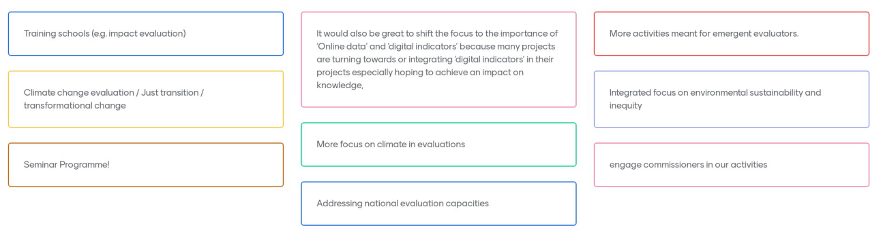
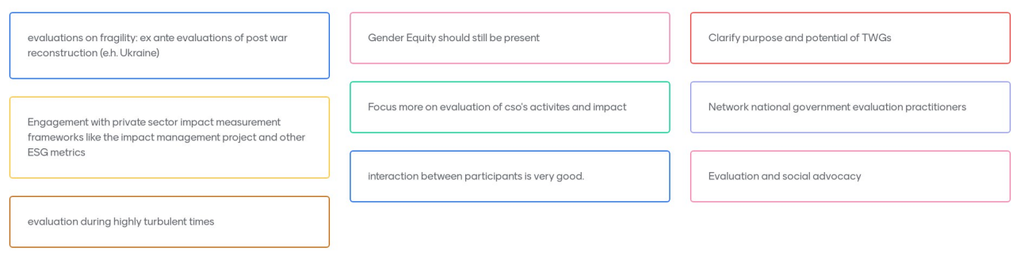
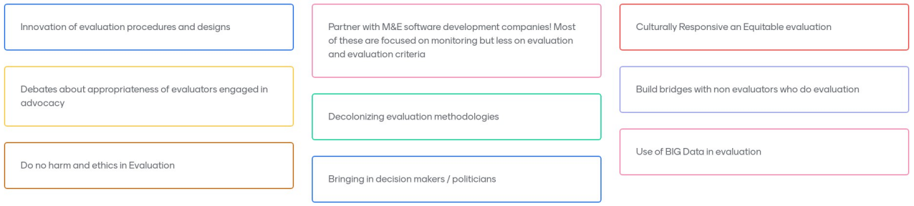
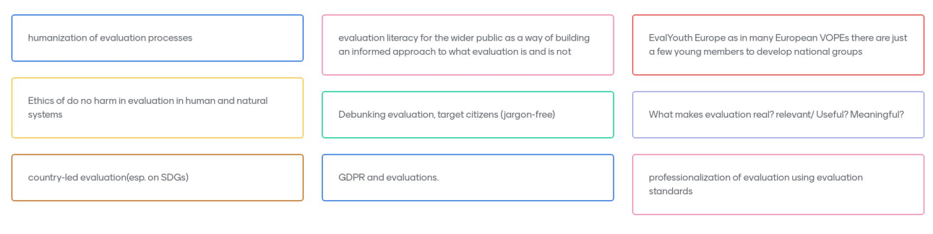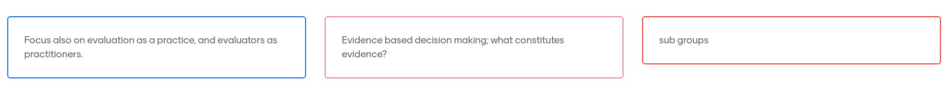

EES to review and consider how to take forward contributions.

Taruna Gupta advised the next AGM would be online in December 2023.

As there was no further business, the President declared the AGM closed. He wished all a very happy festive season and a wonderfully well evaluated 2023.

Sharon Scotcher
14 December 2022

